NEW TORONTO LAWN BOWLING CLUB (NTLBC) REGISTRATION FORM - 2024
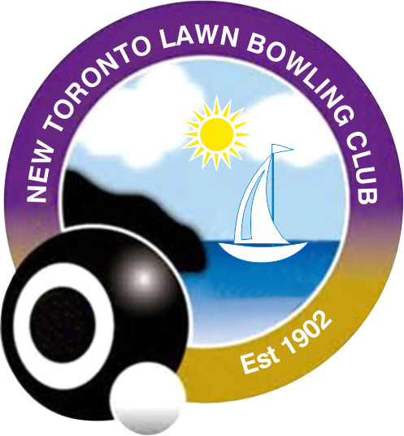
www.newtorontolawnbowlingclub.ca

Name: Click or tap here to enter text. | Tel: Click or tap here to enter text. |  | Cell: Click or tap here to enter text.
Address: Click or tap here to enter text. |  | Apt/Unit #: Click or tap here to enter text.
City: Click or tap here to enter text. | Postal code: Click or tap here. |  |  | Date: Click or tap to enter
Email: Click or tap here to enter text.
Your email information will not be shared with any third parties and will only be used for our Club communications.
Do you consent to your photo on our website? Yes☐ No ☐
Do you have your own bowls? Yes☐ No ☐
Membership and Rentals: (includes $40 OLBA fee)
☐ New Member $175 ☐ Full Member $175 ☐ Associate Member $35 (social or non-players)
☐ Bowls Rental $20 per year - (First year free for New Members)
☐ Locker Rental $10 per bowler - (for members with own bowls)  
☐ Joint Membership $135 - (with another club, requires your OLBA#)
Associate Club: Click or tap here to enter text. OLBA # Click or tap here to enter text.
Total Cheque or Cash amount $ Click or tap here to enter Total E-Transfer Amount $ Click or tap
Cheques payable to: New Toronto Lawn Bowling Club
Mail with your completed form to: Helen Semchyschyn, 49 Green Lanes, Etobicoke, ON M8Z 4V8
or
E-Transfer funds to this email: newtorontolawnbowling@outlook.com
Email your completed online form to: newtorontolawnbowling@outlook.com

NEW BOWLERS: Have you lawn bowled previously? Yes ☐ No ☐ 
How did you hear about us? Friend ☐ Family ☐ Walk-up ☐ Website ☐ Other ☐ : Click or tap here to enter text.

Emergency contact: | Phone number: Click or tap here to enter text.

Volunteer Information: I understand that the club has no paid staff and depends on volunteers to successfully run the club and keep costs to a minimum. All members are expected to agree to volunteer their time and occasionally help out around the club. Volunteering offers many different opportunities to join in, your participation is needed and appreciated. Please initial to acknowledge you agree to be contacted via email or phone as the need for help arises and we may call on you to co-ordinate your assistance.

Please click the box as your digital initial. ☐

Please assist our Government and OLBA reporting requirements and Grant applications by providing the following information

Date of Birth: Mandatory for Membership and OLBA Insurance coverage
Gender: Male ☐ Female ☐ Non-Binary ☐ Other ☐ Rather not say ☐
Certified Coach: Yes ☐ No ☐ Level 1 Level 2 Level 3
Certified Umpire: Yes ☐ No ☐ Level 1 Level 2 Level 3

